**Newsroom portfolio website:**

**Project Structure:**

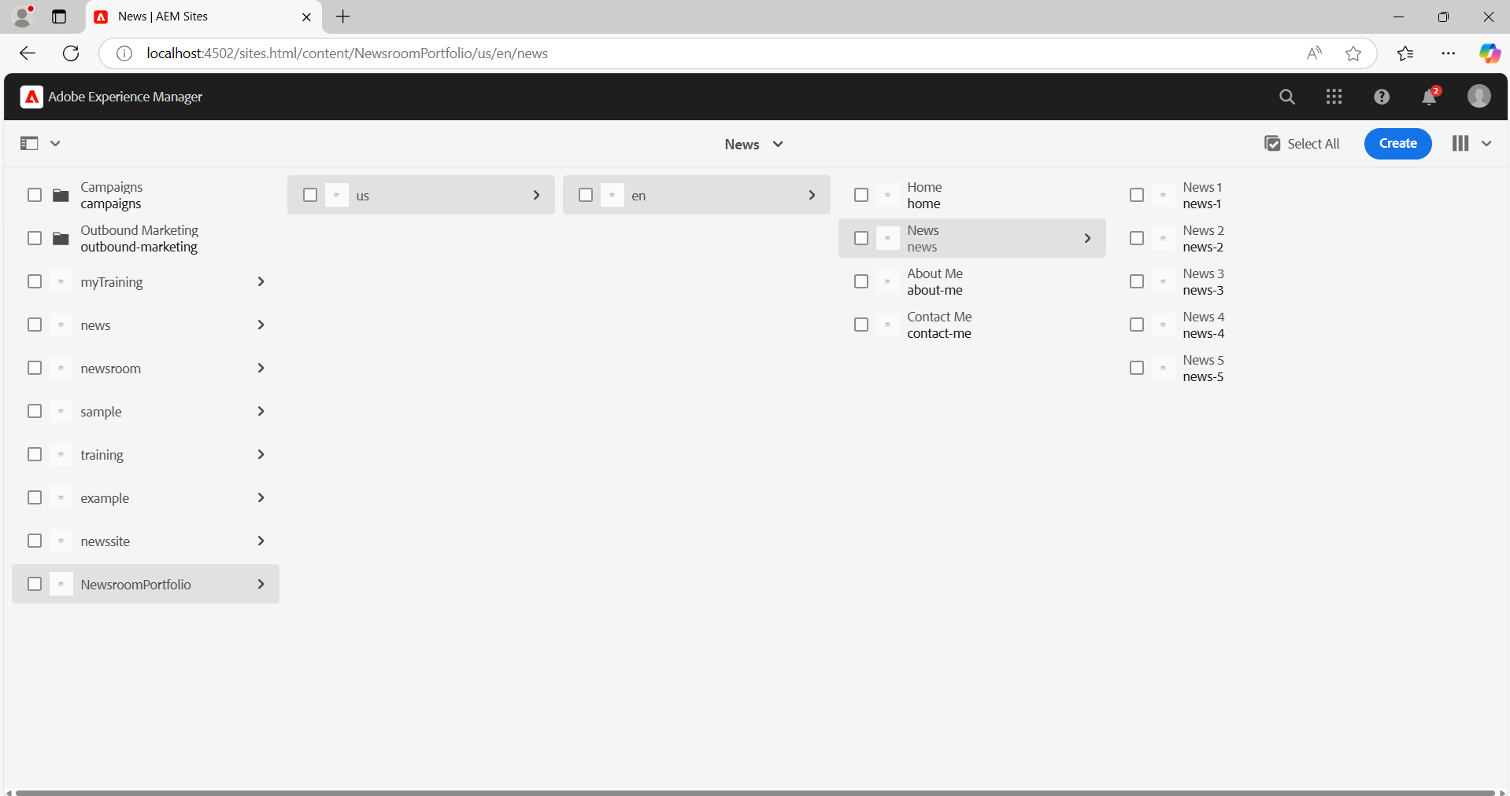

**1. Use the OOTB header component and create news(5), about me, contact me, and homepage. These pages should come in a header with proper styling and make sure books have a drop-down, so news should come.(The header should be used at the template level, so every page can use them).**

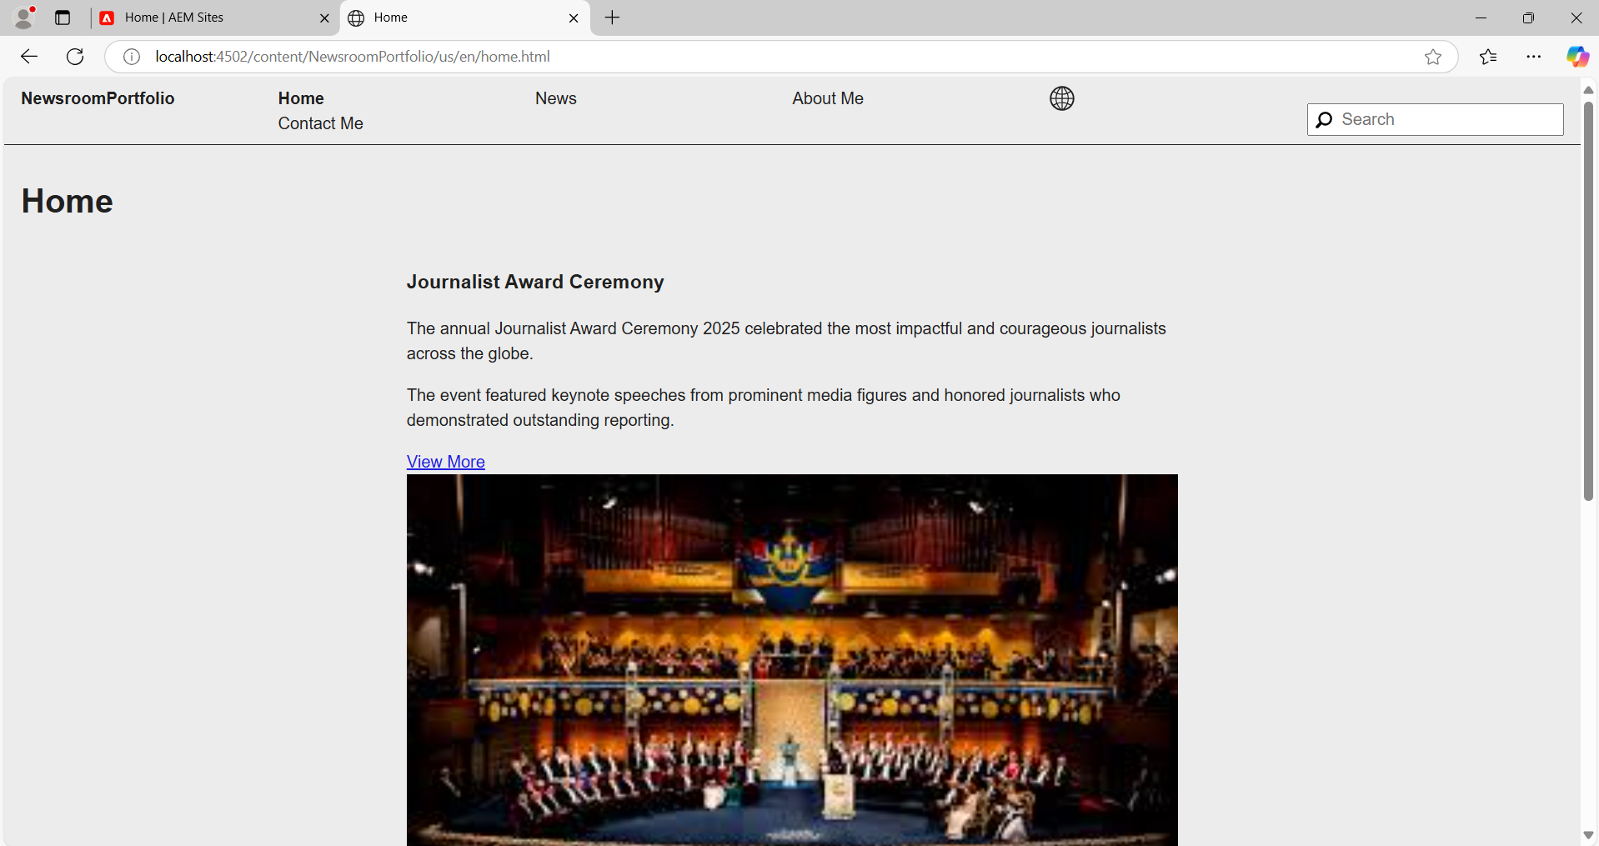

**2. Footer sections: About me, contact me, the latest 5 news-lists with hyperlinks should be opened in a new tab, and social media section.(The footer should be used at the template level, so every page can use them).**

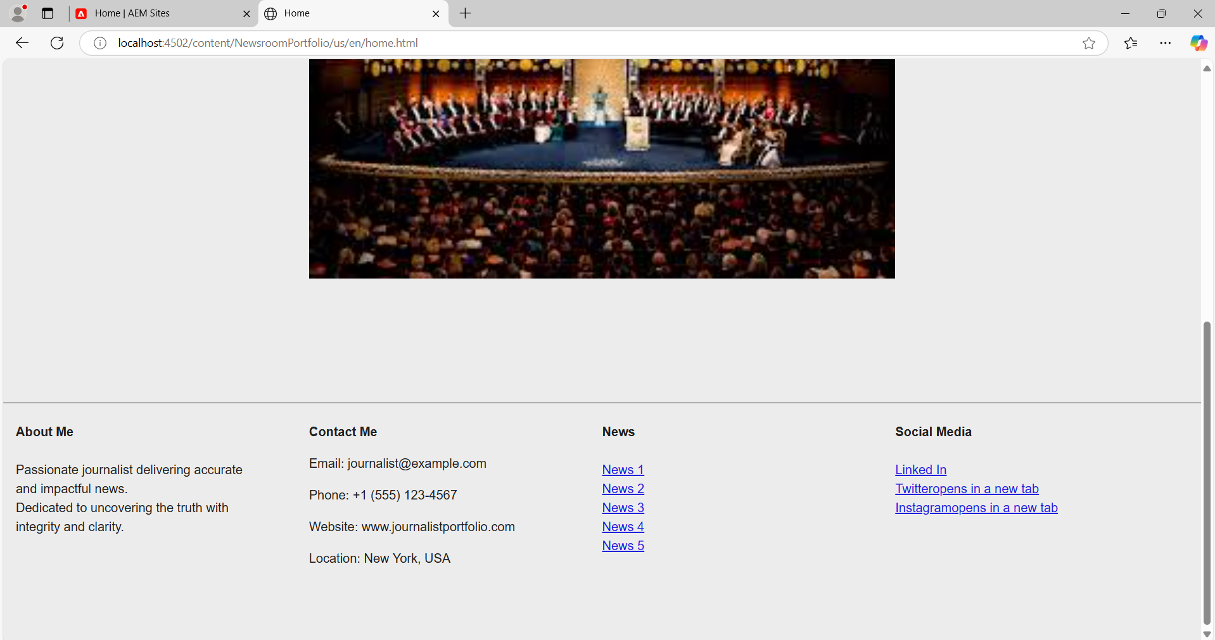

**3. Homepage: Use a teaser component to display some award ceremony for journalists so that it can have an image, title, some description, and a CTA (which will link to that page where the user can use the entire news for that award. The page will be created and authored in CTA).**

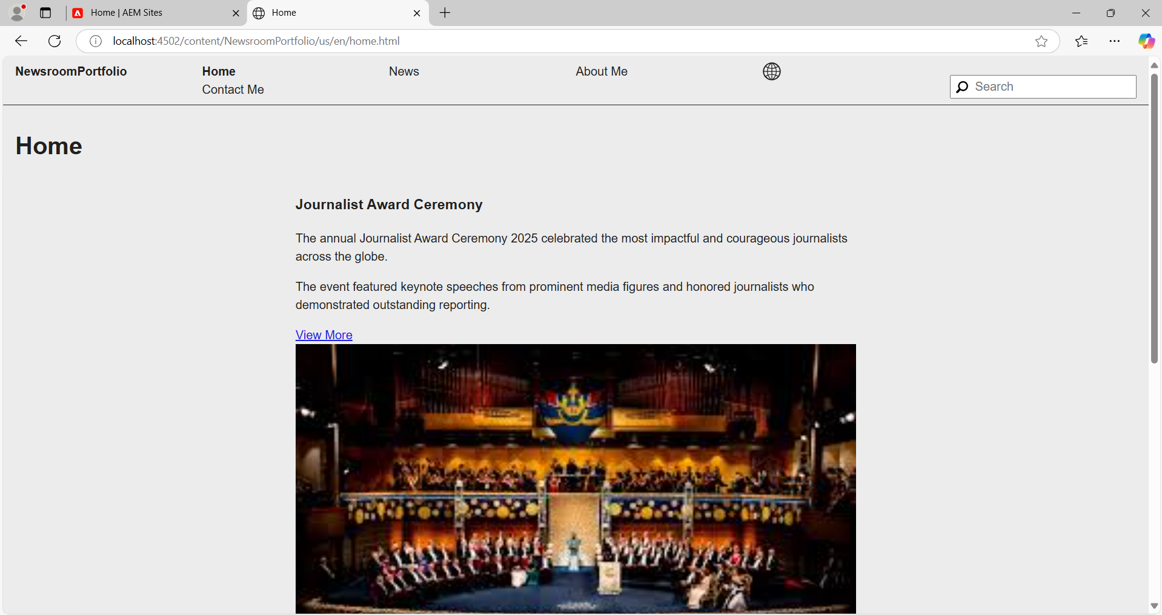

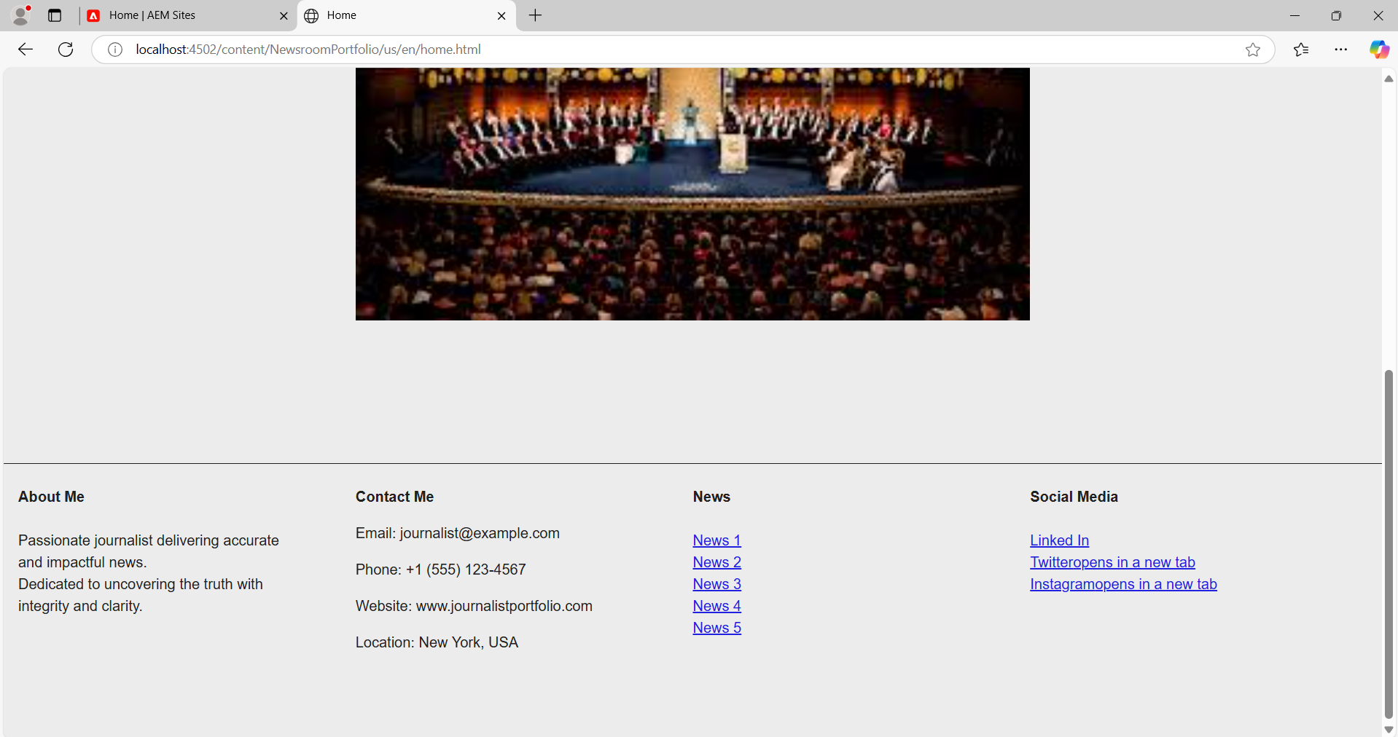

**4. News page: Create a NewsRoom component which will get the News page as parent path (news page should be authored). This component should fetch all the news created under the /contact/news folder and make sure all the books should be placed under the /content/news folder. Create news article pages under /content/news hierarchy and author the page with title, image, and text component, so that when the NewsRoom component is authored, it fetches these properties from each page to show on the news page as cards. Each card should have Title, news details, and image, and make sure each card has a unique title, description, and image.**

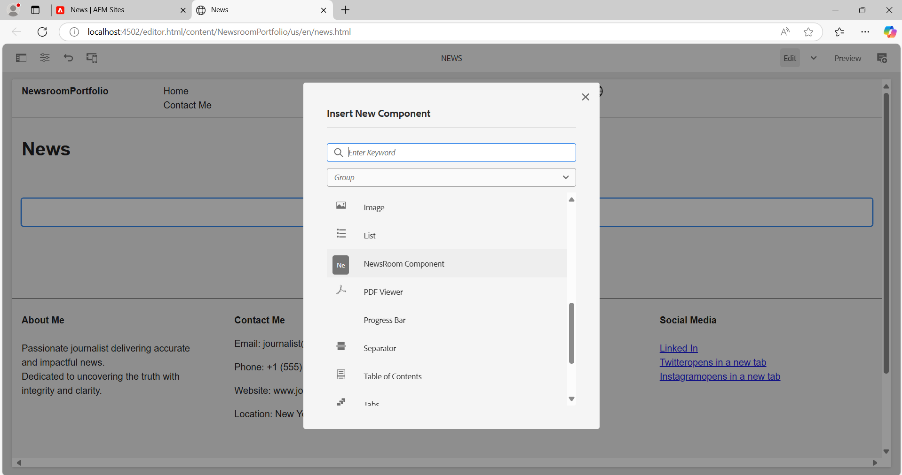

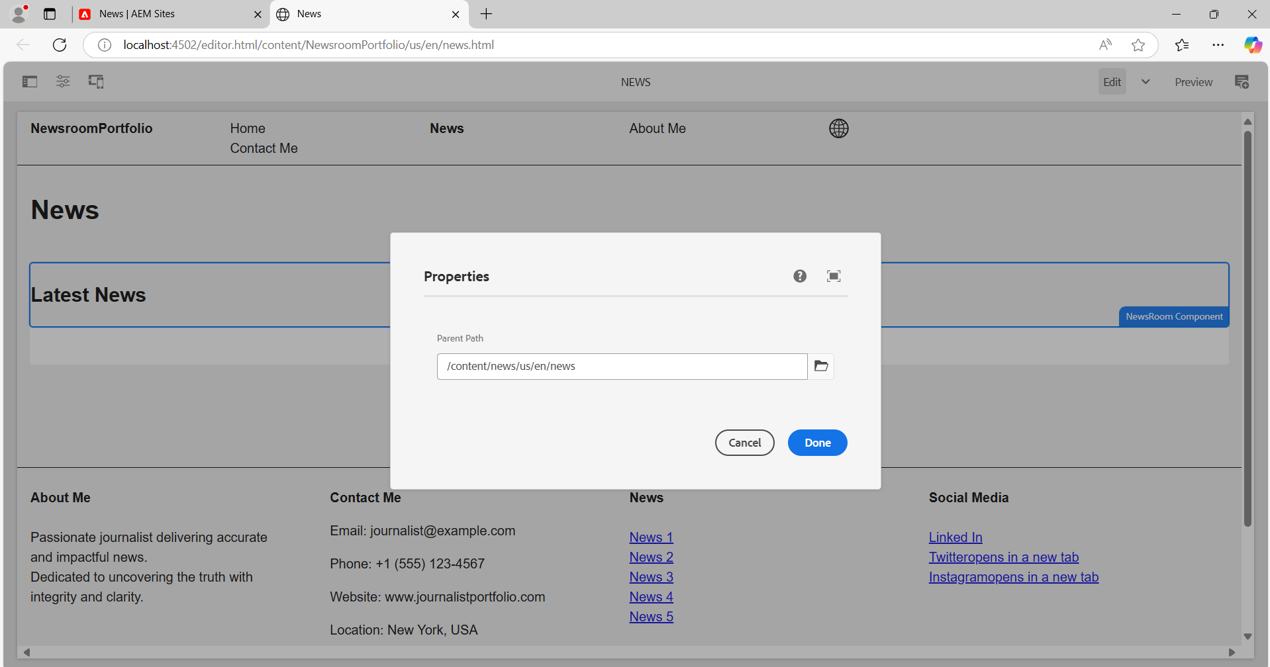

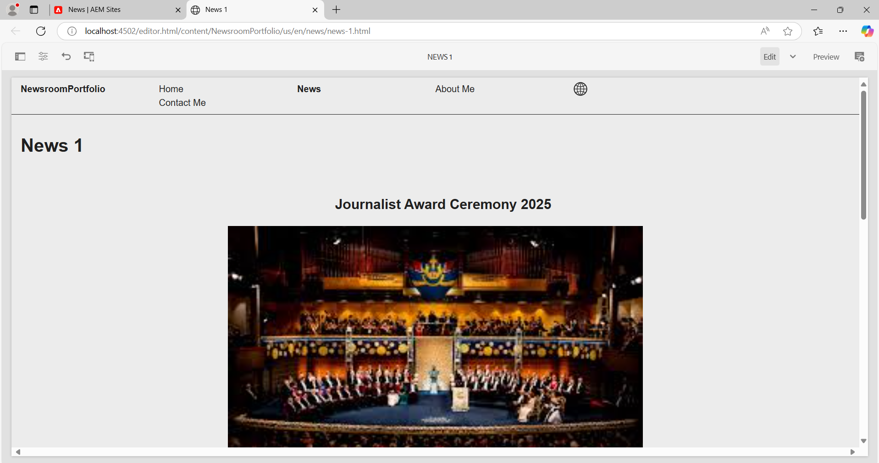

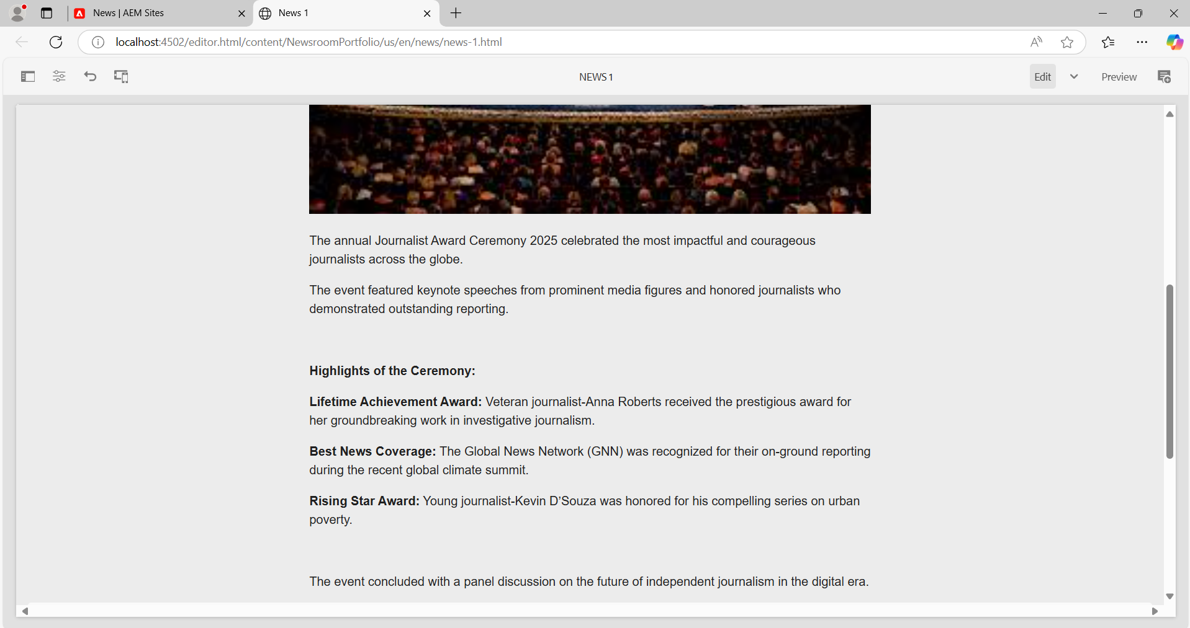

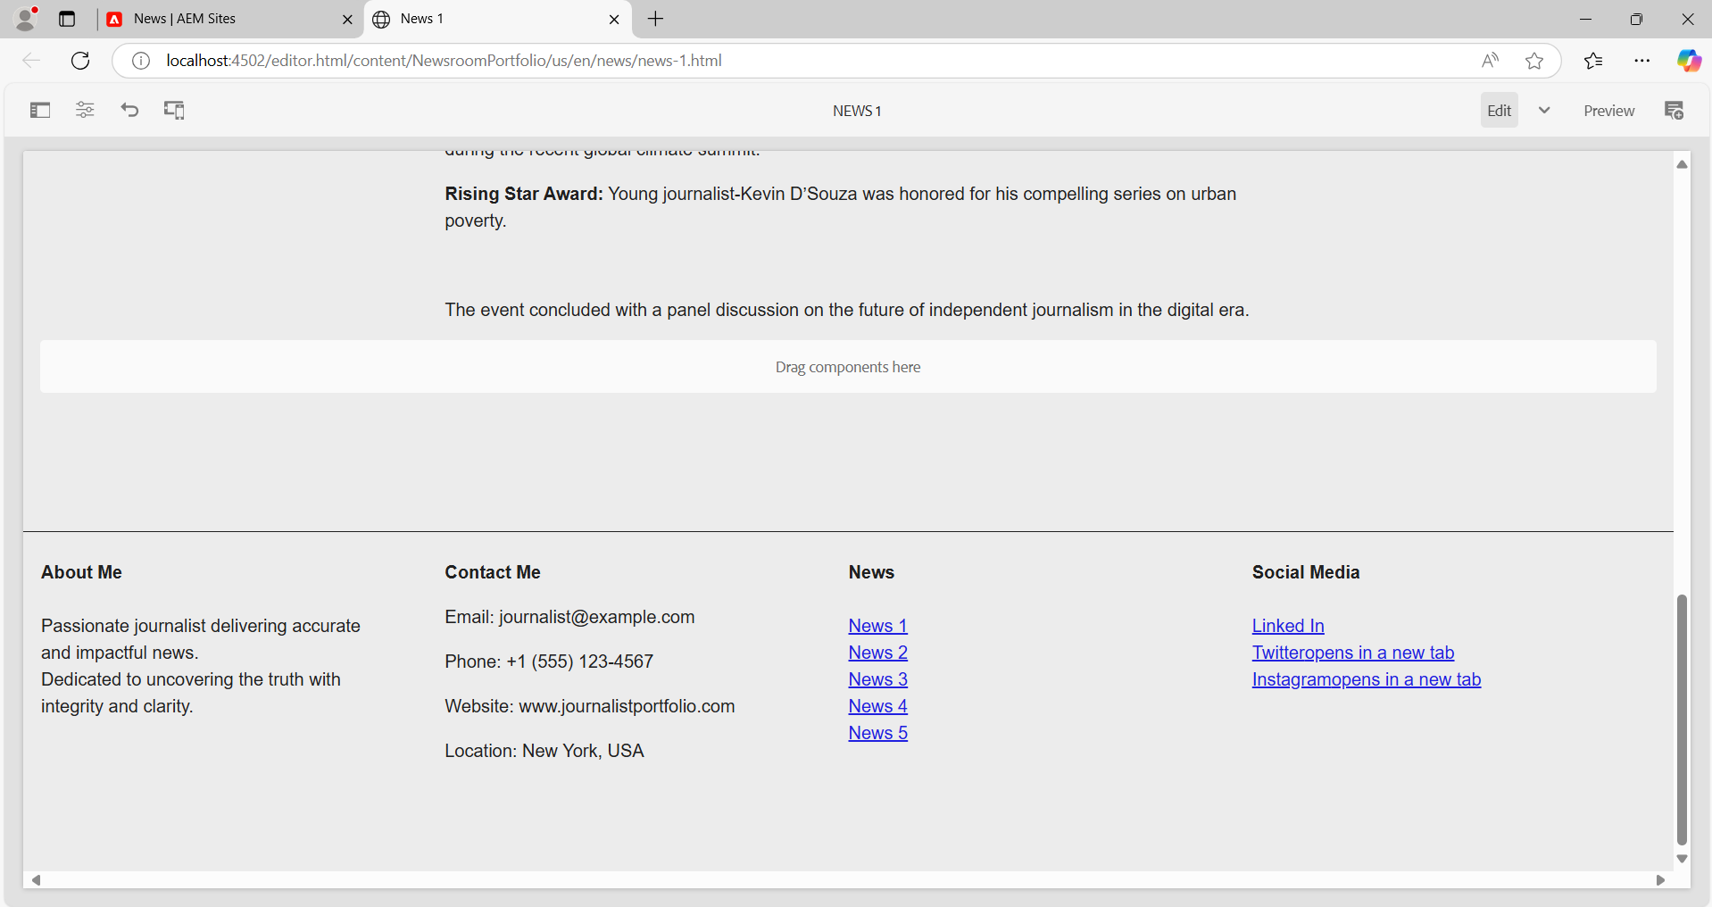

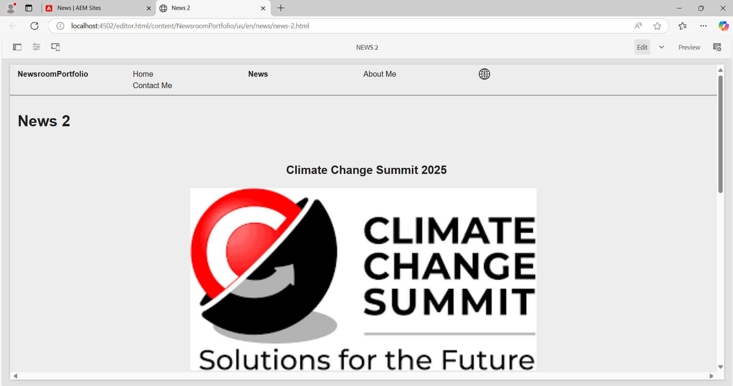

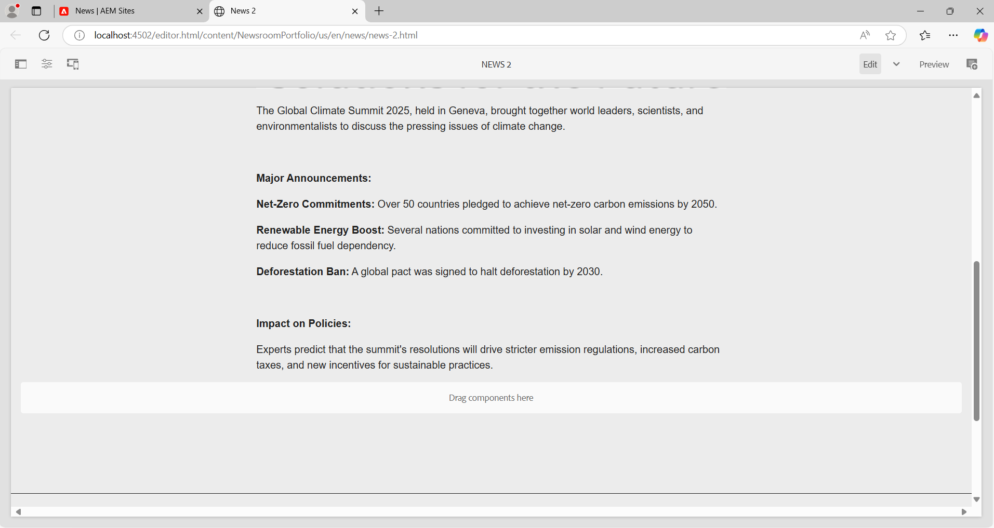

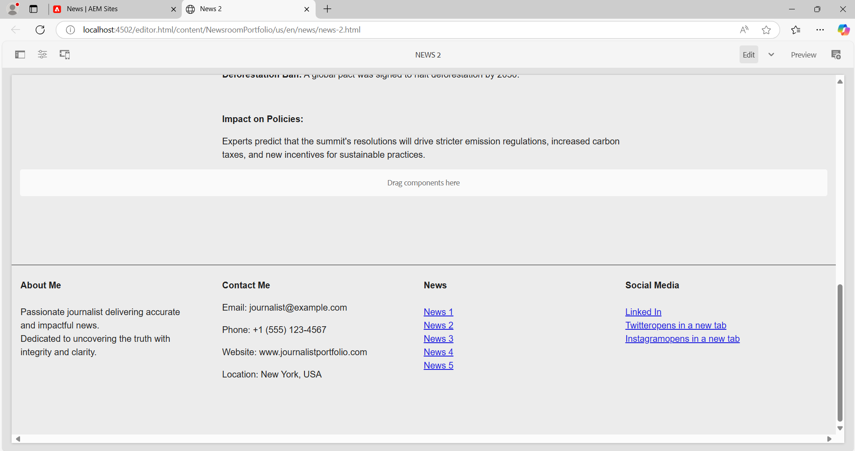

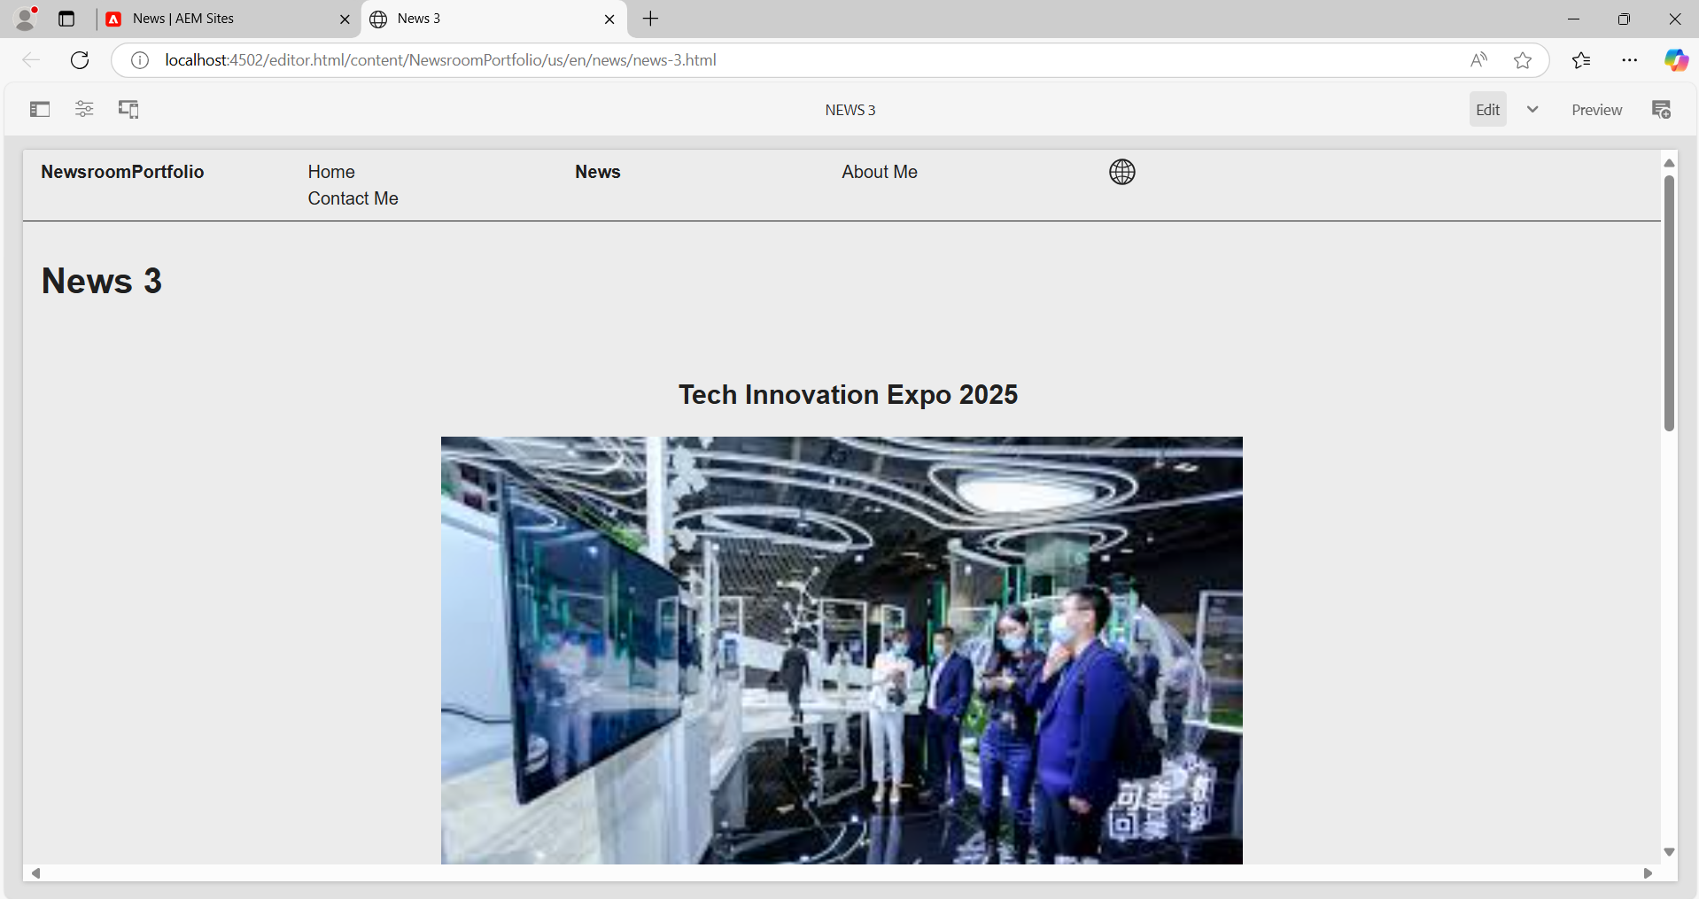

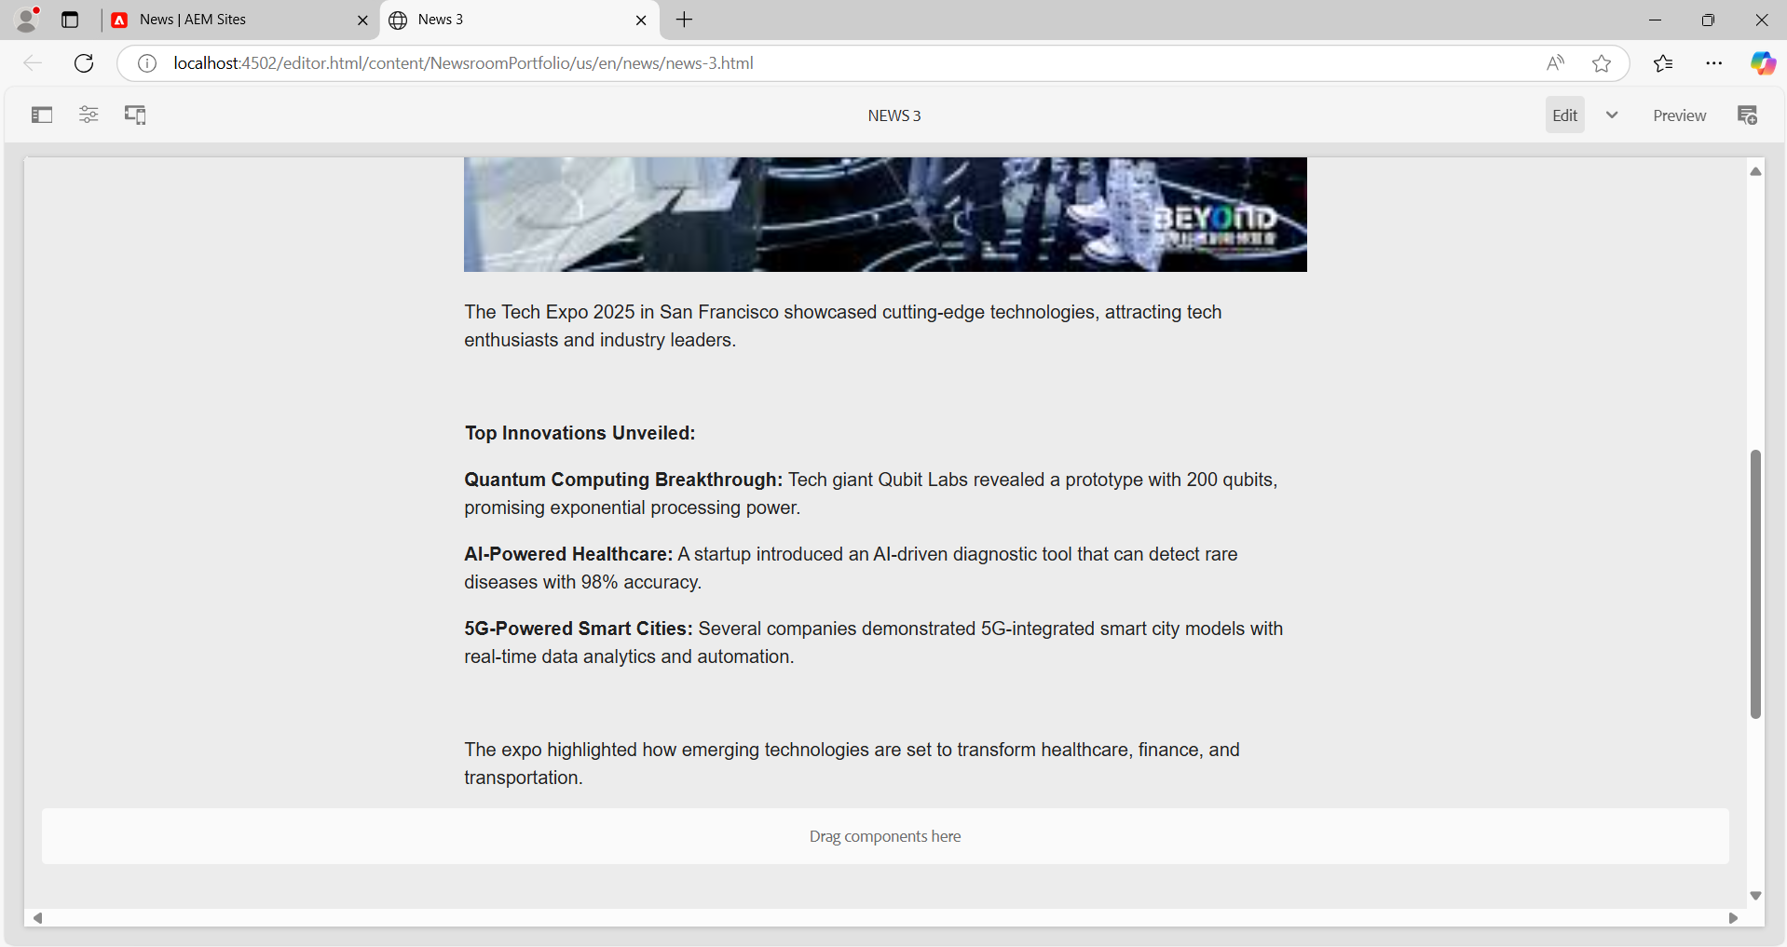

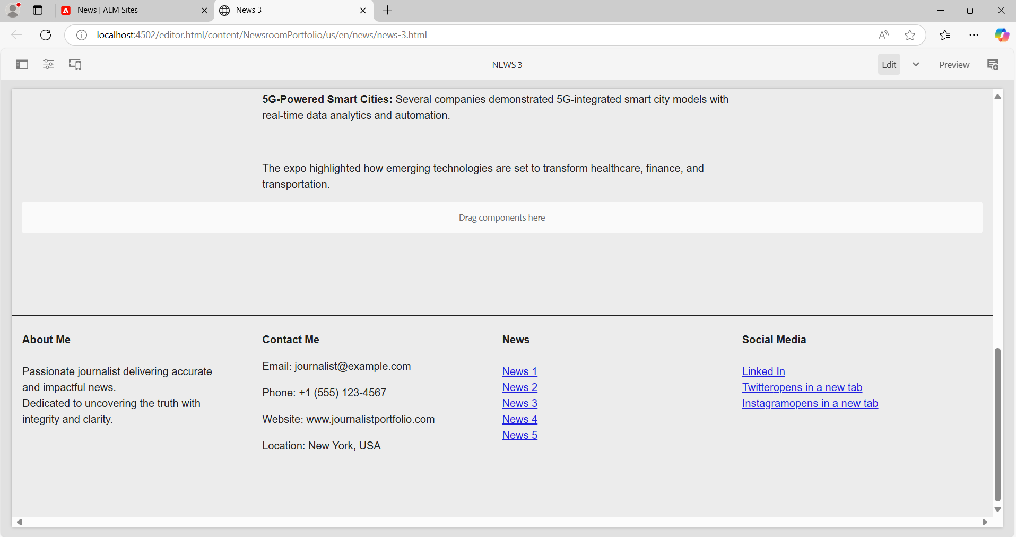

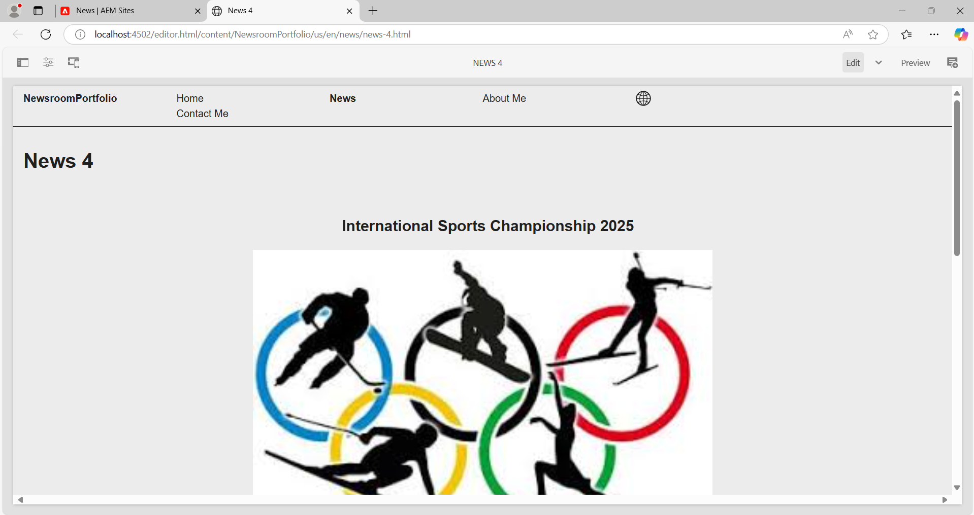

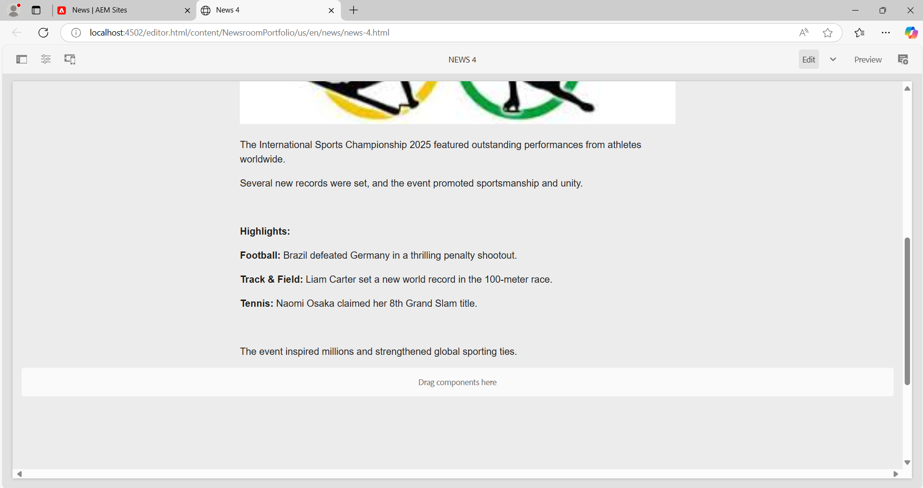

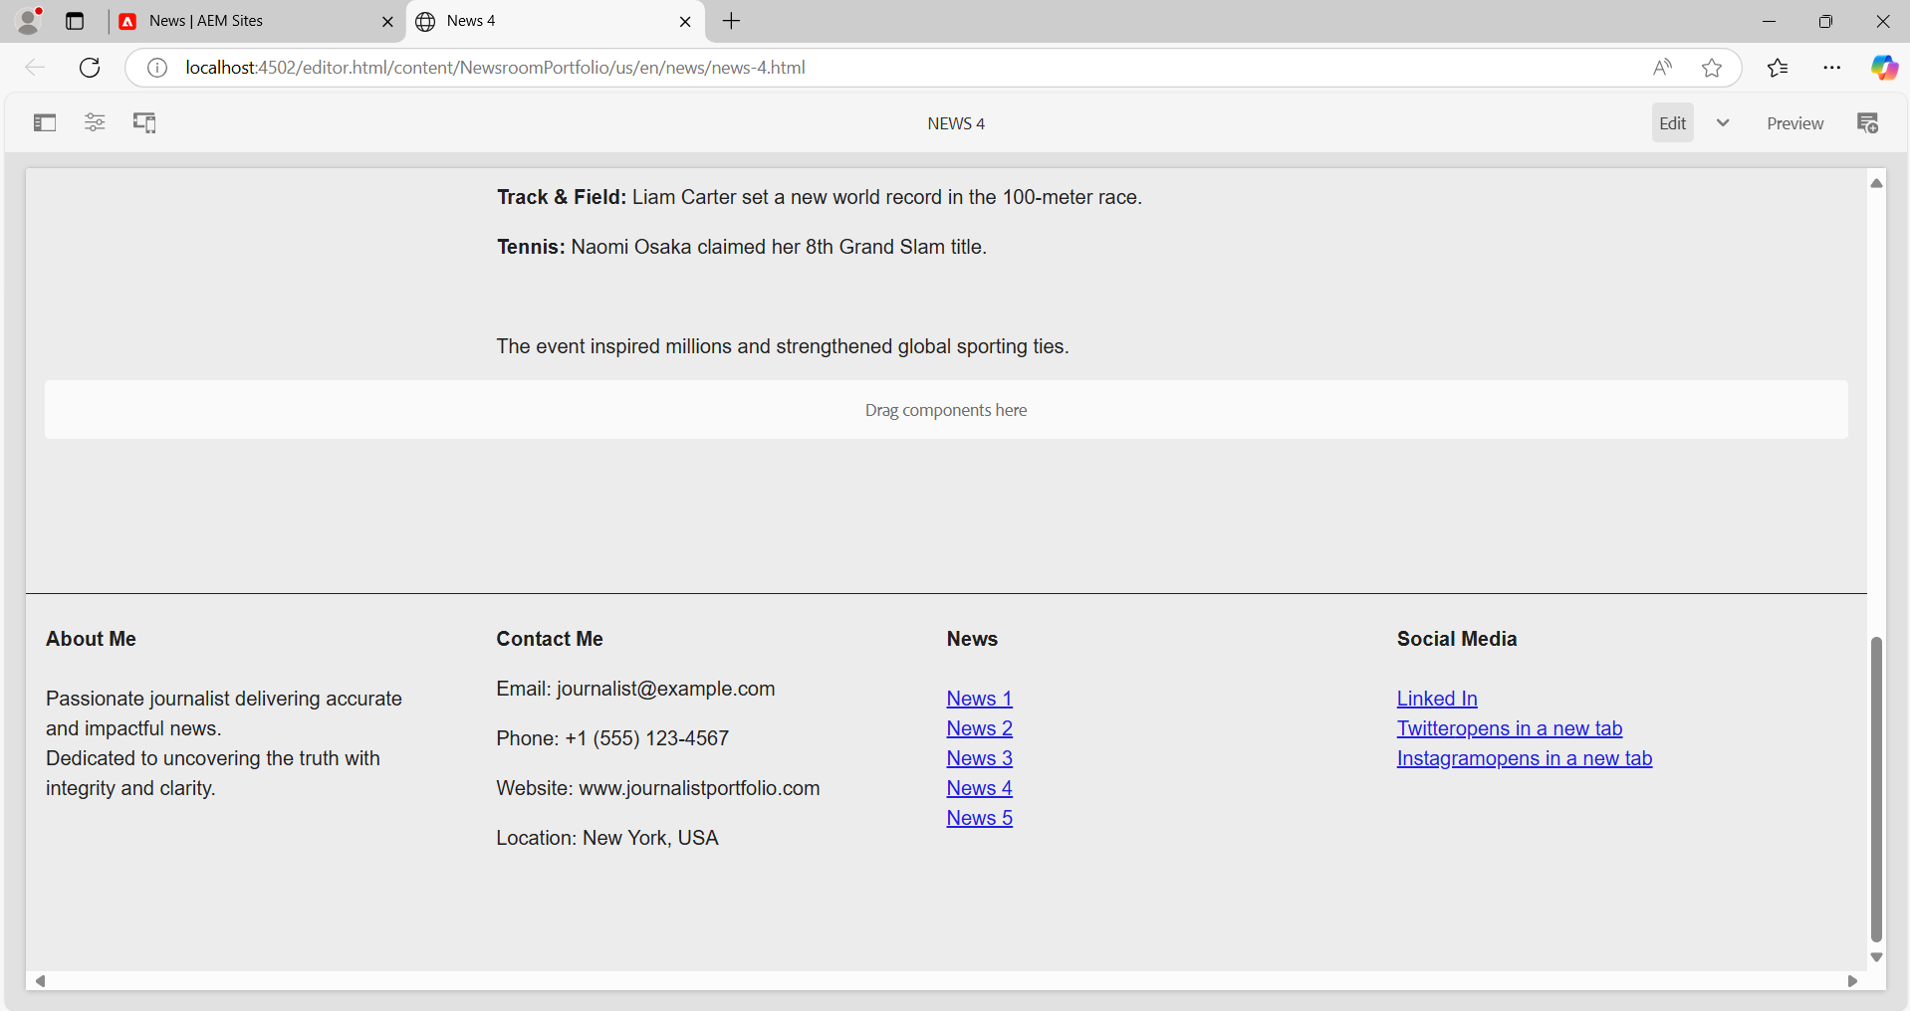

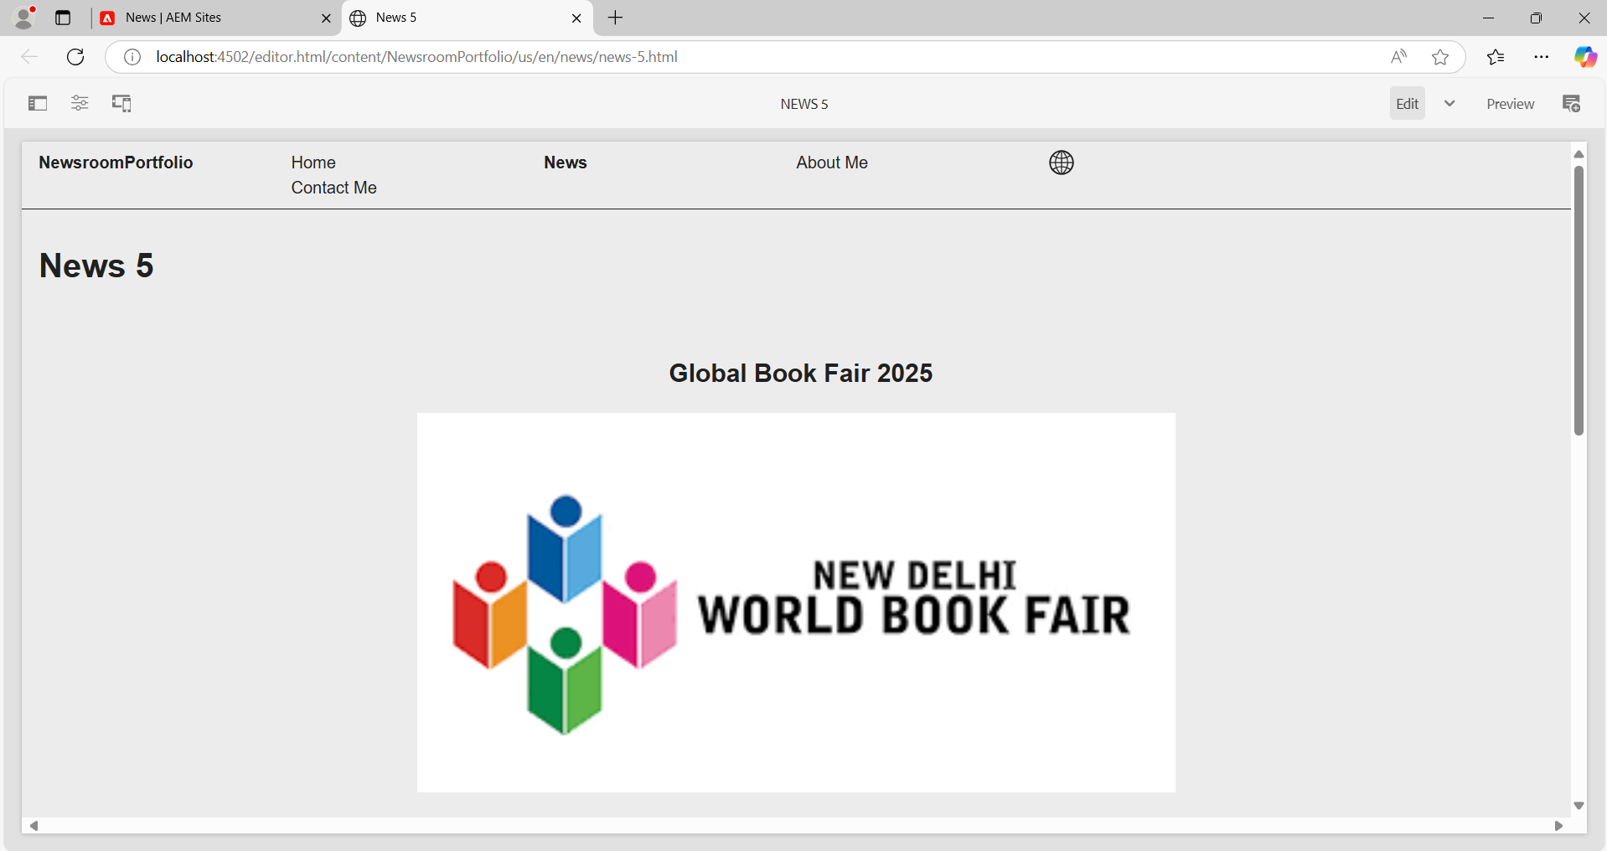

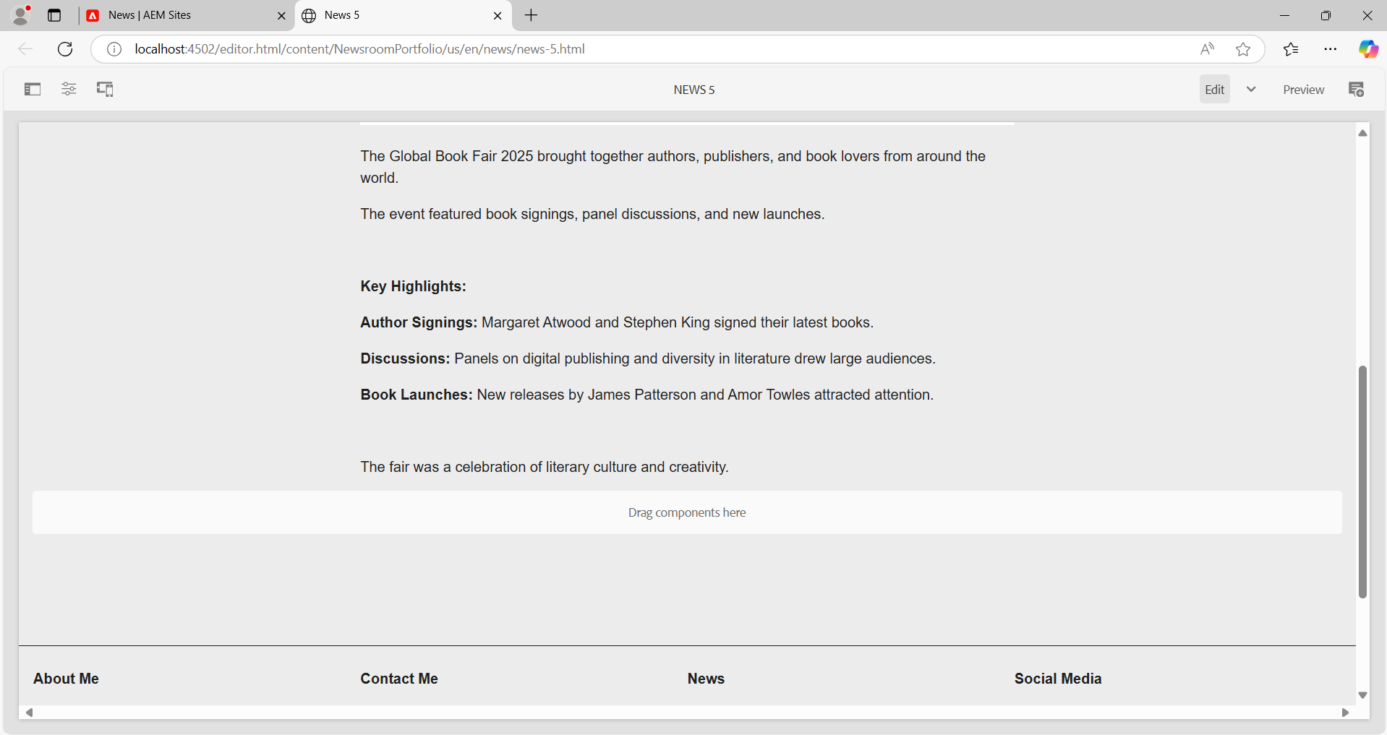

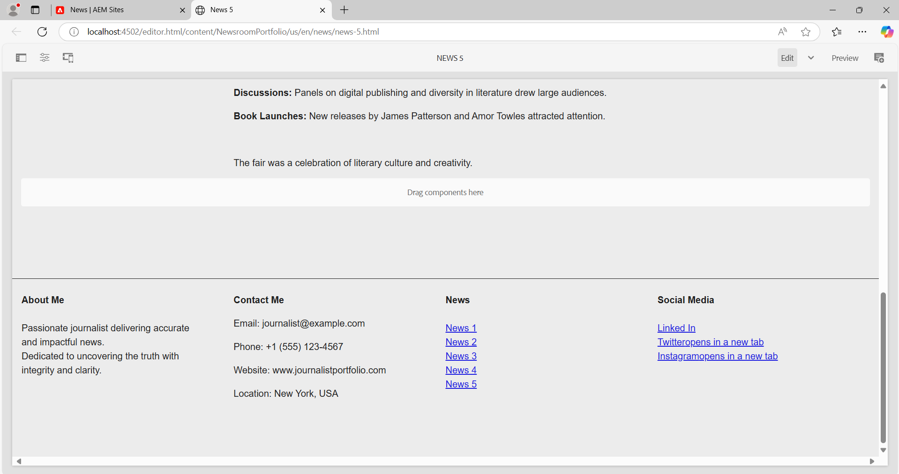

**5. About me page: Use the journalist component to provide some information about journalists. Only this component should be used on this page.**

Path: apps/NewsroomPortfolio/components/journalist

**journalist.html**

<div class="cmp-journalist" data-cmp-is="journalist" data-sly-use.model="com.NewsroomPortfolio.core.models.JournalistModel">

<h2 class="cmp-journalist__title">Journalist Component</h2>

<div class="cmp-journalist__item" data-sly-test="${properties.journalistName}">

<p class="cmp-journalist__label">Journalist Name:</p>

<pre class="cmp-journalist__output">${properties.journalistName}</pre>

</div>

<div class="cmp-journalist__item" data-sly-test="${properties.bio}">

<p class="cmp-journalist__label">Biography:</p>

<pre class="cmp-journalist__output">${properties.bio}</pre>

</div>

</div>

**.content.xml**<?xml version="1.0" encoding="UTF-8"?>

<jcr:root xmlns:cq="http://www.day.com/jcr/cq/1.0"

xmlns:jcr="http://www.jcp.org/jcr/1.0"

jcr:primaryType="cq:Component"

jcr:title="Journalist Component"

componentGroup="NewsroomPortfolio - Content"/>

Path: com/NewsroomPortfolio/core/models

**JournalistModel.java**package com.NewsroomPortfolio.core.models;

import org.apache.sling.api.resource.Resource;

import org.apache.sling.models.annotations.DefaultInjectionStrategy;

import org.apache.sling.models.annotations.Model;

import org.apache.sling.models.annotations.injectorspecific.ValueMapValue;

import javax.inject.Inject;

@Model(adaptables = Resource.class, defaultInjectionStrategy = DefaultInjectionStrategy.OPTIONAL)

public class JournalistModel {

@Inject

@ValueMapValue

private String journalistName;

@Inject

@ValueMapValue

private String bio;

public String getJournalistName() {

return journalistName;

}

public String getBio() {

return bio;

}

}

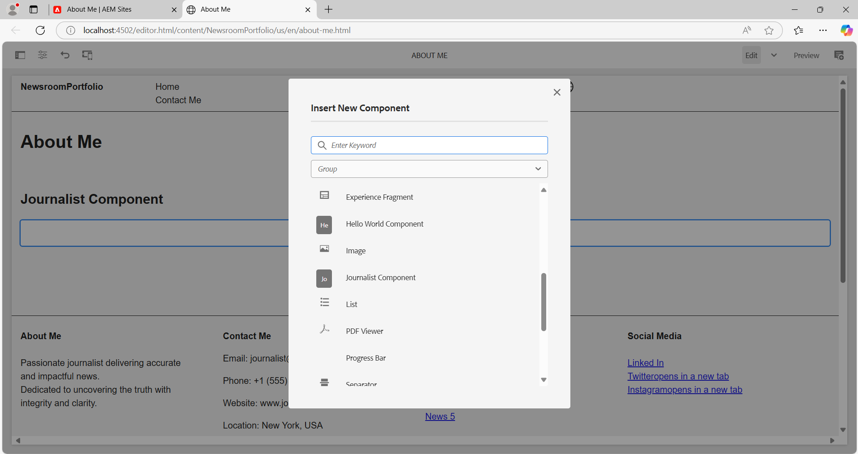

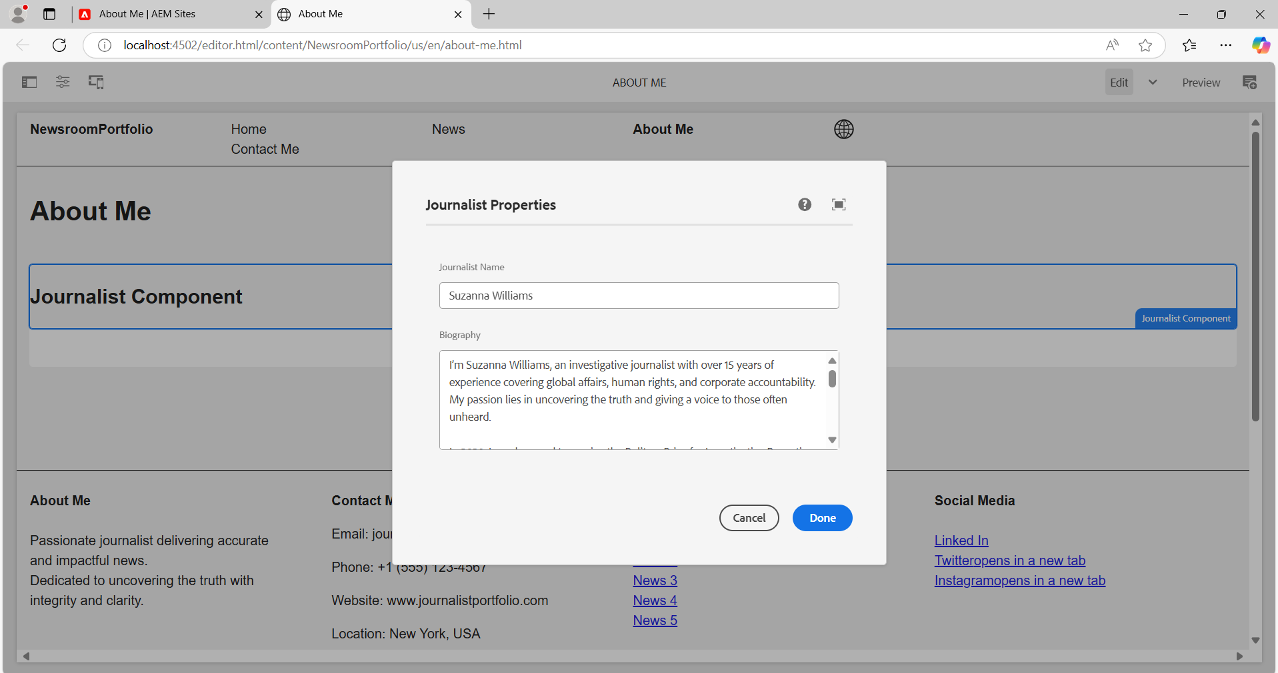

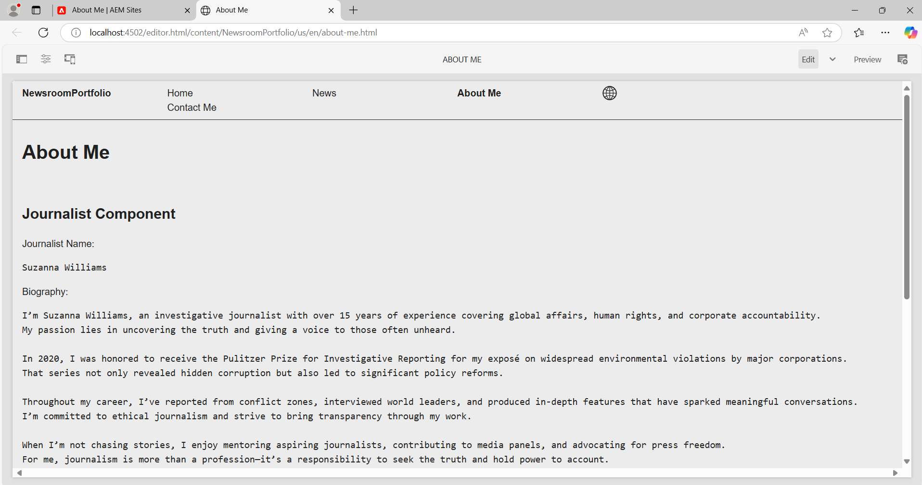

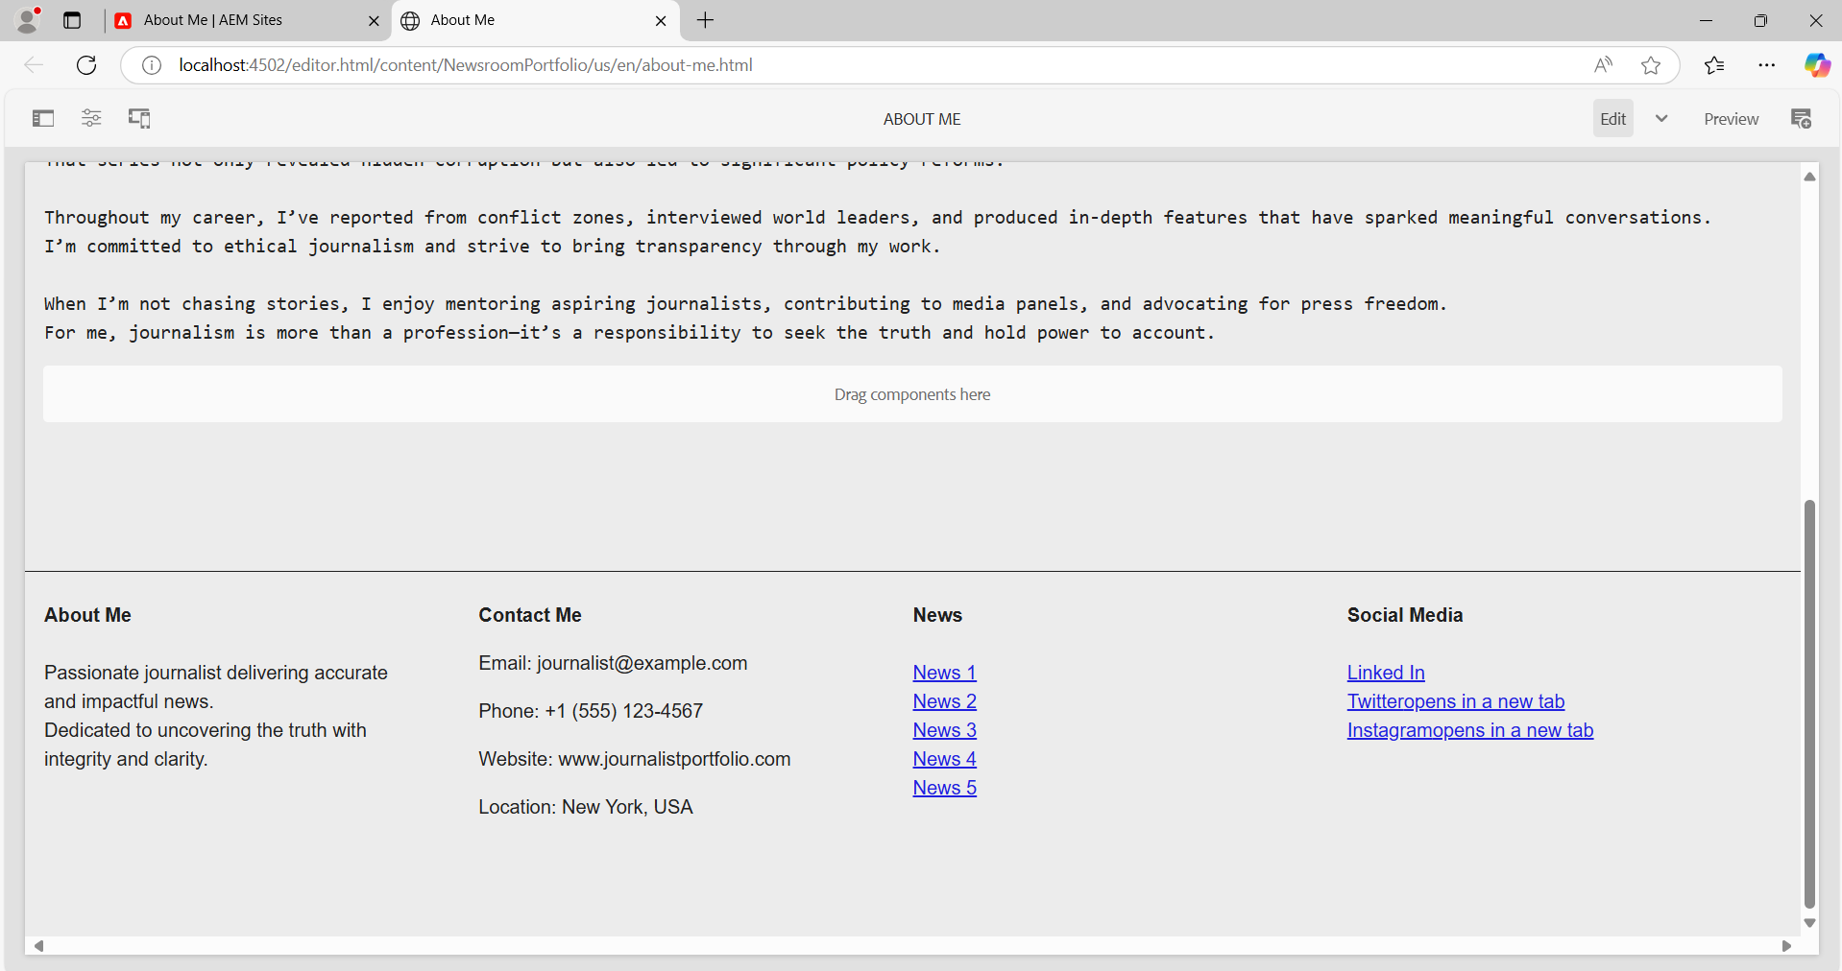

**6. Contact me page: Use text or teaser components to provide contact details to connect with the author or some social media profile links, so anybody can follow him on social media platforms.**

